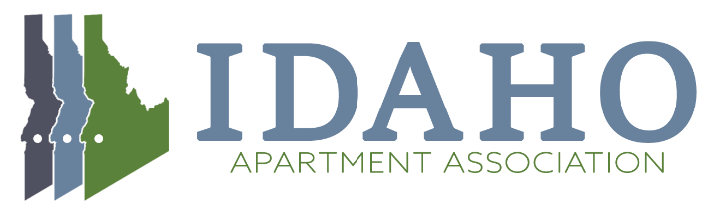
Education Committee Agenda
February 17th, 2022 11:30 AM

- Welcome and Introductions

- Membership Meeting Schedule 2022 - Speakers
  - March Meeting – Restoration & Remediation
    - ServPro – Robin Fielder? Need pic and bullet points for marketing.
  - April Meeting - Security Deposits - Calculating Final Charges or Refunds
    - Colburn’s office?
  - May Meeting - ESA's and Fair Housing
    - Who? Right after the conference, should we do a different topic?

- Fair Housing Classes
  - Virtual Meeting February 18th, 2022 – Statewide
  - April 20th Fair Housing Conference – Live training in Boise
  - June 14th, 2022 – Idaho Falls Live
  - June 15th, 2022 – Twin Falls Live
  - September 16th Coeur D’aLene – Live Class

- 2022 Fair Housing Conference – April 20th, 2022
  - Review 2021 Schedule
  - Draft 2022 Schedule
- Additional Business

